How to execute Python script **“crtable.py”** from command prompt?

1. **To create a table in MySQL database**

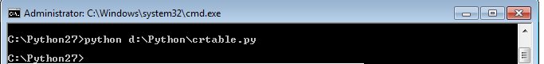

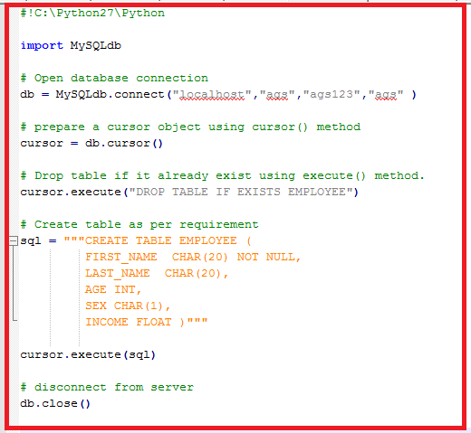

1. **Insert data into MySQL table**

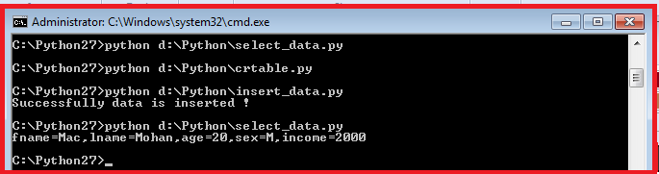

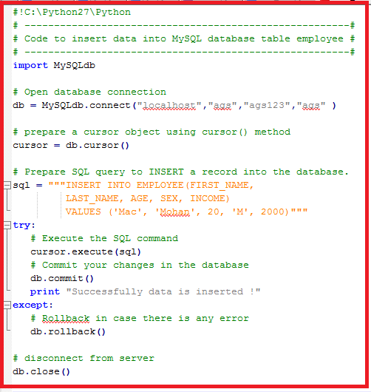

1. **Code to query for selecting records having income more than $1000.**

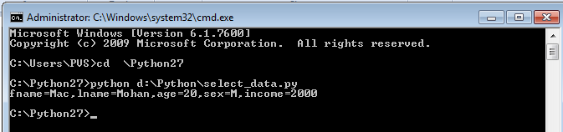

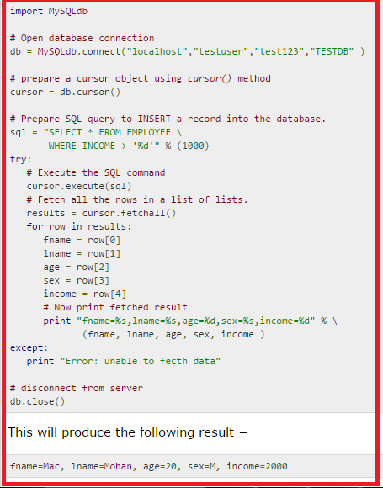

1. **Code to query for update records having having SEX as 'M'. Here, we increase AGE of all the males by one year.**

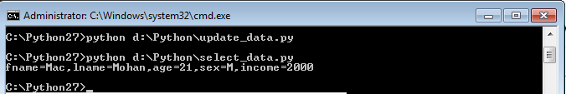

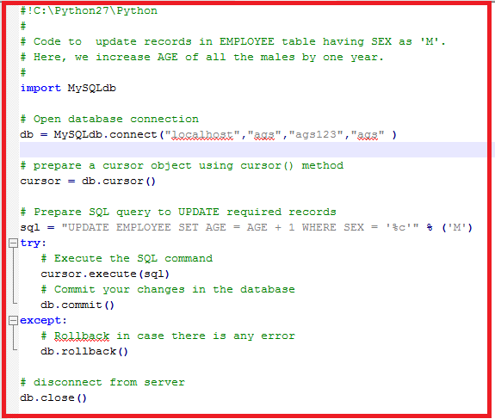

1. **Code to delete records having age more than 20 from EMPLOYEE table.**

